Solve following questions:

1.     Write a program that takes a student's score as input and outputs the corresponding grade based on the following scale:

A: 90-100

B: 80-89

C: 70-79

D: 60-69

F: 0-59

INPUT:-

**package** Grade;

**import** java.util.Scanner;

**public** **class** Grade {

**public** **static** **void** main(String[] args) {

// **TODO** Auto-generated method stub

// Create a Scanner object to read input//

Scanner obj=**new** Scanner(System.***in***);

//getting input from user//

System.***out***.println("Enter the Score: ");

**int** Score=obj.nextInt();

**char** grade;

//for giving the grade based on the input//

**if**(Score>=90 && Score<=100)

{

System.***out***.println("Grade is A");

}

**else** **if**(Score>=80 && Score<=89)

{

System.***out***.println("Grade is B");

}

**else** **if**(Score>=70 && Score<=79)

{

System.***out***.println("Grade is C");

}

**else** **if**(Score>=60 && Score<=69)

{

System.***out***.println("Grade is D");

}

**else** **if**(Score>=0 && Score<=59)

{

System.***out***.println("Grade is E");

}

**else** {

System.***out***.println("please enter the valid number from 0 to 100");

}

//scanner close

obj.close();

}

}

OUTPUT:-

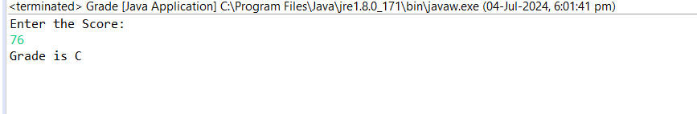

2.     Write a program to check if a given year is a leap year. (A year is a leap year if it is divisible by 4 but not by 100, or it is divisible by 400.)

INPUT:-

**package** leapYear;

**import** java.util.Scanner;

**public** **class** LeapYear {

**public** **static** **void** main(String[] args) {

// **TODO** Auto-generated method stub

// Create a Scanner object to read input//

Scanner sc=**new** Scanner(System.***in***);

System.***out***.println("enter the year: ");

**int** year=sc.nextInt();

//for printing the leap year//

**boolean** LeapYear=(year % 4 == 0 && year % 100 != 0)||(year % 400 == 0 );

**if**(LeapYear) {

System.***out***.println(year+"this is LeapYear");

}

**else** {

System.***out***.println(year+"this is not a LeapYear");

}

// Close the scanner//

sc.close();

}

}

OUTPUT:-

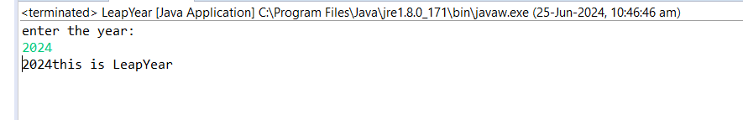

3.     Write a program that takes an integer as input and checks if it is positive, negative, or zero.

INPUT:-

**package** positiveNegativeNumber;

**import** java.util.Scanner;

**public** **class** PositiveNegavtive {

**public** **static** **void** main(String[] args) {

//// Create a Scanner object to read input//

Scanner sc=**new** Scanner(System.***in***);

System.***out***.println("enter the integer number: ");

**int** num=sc.nextInt();

//for checking positive number//

**if**(num>0)

{

System.***out***.println("the number is positive");

}

//for checking negative number//

**else** **if**(num<0)

{

System.***out***.println("the number is negative");

}

//for checking the number is zero or not

**else** {

System.***out***.println("the number is zero");

}

// Close the scanner//

sc.close();

}

}

OUTPUT:-

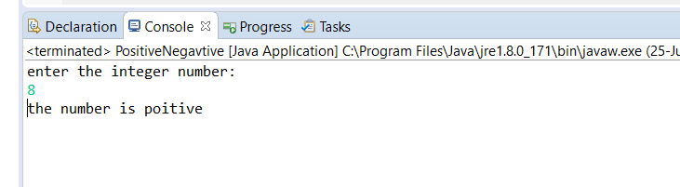

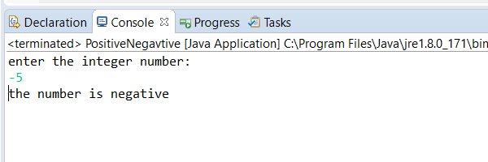

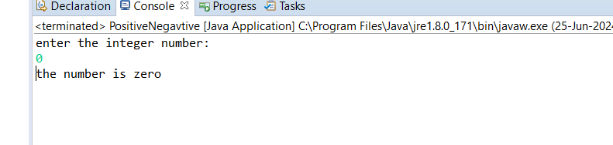

4.     Write a program that prints numbers from 1 to 10 using a loop.

INPUT:-

**package** forLoop;

**public** **class** ForLoop {

**public** **static** **void** main(String[] args) {

// **TODO** Auto-generated method stub

//For printing 1 to 10 numbers in loop//

**for**(**int** i=1; i<=10;i++)

{

// Print the total//

System.***out***.println(i);

}

}

}

OUTPUT:-

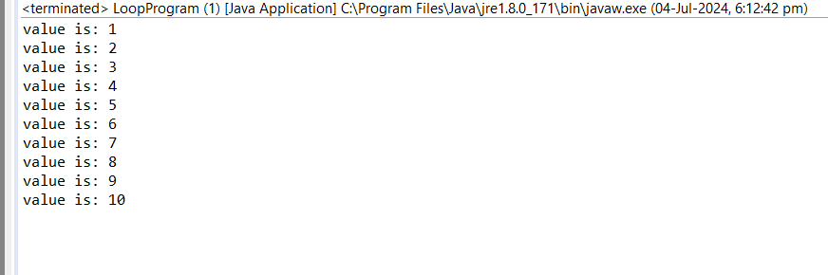

5.     Write a program that takes an integer N as input and calculates the sum of entered numbers.

INPUT:-

**package** sumOfNumber;

**import** java.util.Scanner;

**public** **class** SumOfNumbers {

**public** **static** **void** main(String[] args) {

// Create a Scanner object to read input

Scanner scanner = **new** Scanner(System.***in***);

// Prompt the user to enter the number of elements

System.***out***.print("Enter the number of elements: ");

**int** N = scanner.nextInt();

// Initialize the sum to zero

**int** totalSum = 0;

// Loop to get each number and add it to the sum

**for** (**int** i = 1; i <= N; i++) {

System.***out***.print("Enter number " + i + ": ");

**int** number = scanner.nextInt();

totalSum += number;

}

// Print the total

System.***out***.println("The sum of the entered numbers is: " + totalSum);

// Close the scanner

scanner.close();

}

}

OUTPUT:-

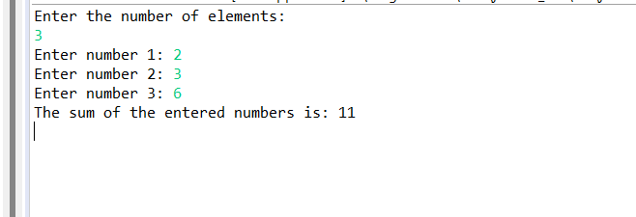

6.     Write a program that takes an integer as input and prints its multiplication table up to 10.

INPUT:-

**package** multiplicationTable;

**import** java.util.Scanner;

**public** **class** MultiplicationTable {

**public** **static** **void** main(String[] args) {

// **TODO** Auto-generated method stub

**int** num;

// Create a Scanner object to read input//

Scanner sc=**new** Scanner(System.***in***);

//gettig input from user//

System.***out***.println("Enter the number: ");

num=sc.nextInt();

//for excuting for getting mutiplication table upto 10//

**for**(**int** i=1;i<11;i++)

//standard format for priting table in proper manner

System.***out***.println(num + "X" + i + " = " + (num * i) );

// Close the scanner//

sc.close();

}

}

OUTPUT:-

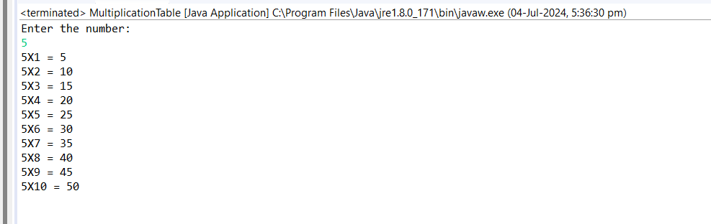

7.     Write a program that takes a positive integer as input and prints its digits in reverse order.

INPUT:-

**package** reverseProblem;

**import** java.util.Scanner;

**public** **class** ReverseOrder {

**public** **static** **void** main(String[] args) {

// **TODO** Auto-generated method stub

// Create a Scanner object to read input//

Scanner sc=**new** Scanner(System.***in***);

//getting output from user//

System.***out***.println("enter the number: ");

**int** num=sc.nextInt();

//checking that number is positive or not//

**if** (num<0) {

System.***out***.println("the number is not positive");

}

//checking that number is negative or not//

**else** {

System.***out***.println("the number is positive");

//for reverse the output//

**while** (num!=0) {

**int** digit=num%10;

System.***out***.print(digit);

num/=10;

}

System.***out***.println();

}

//close Scanner//

sc.close();

}

}

Output:-

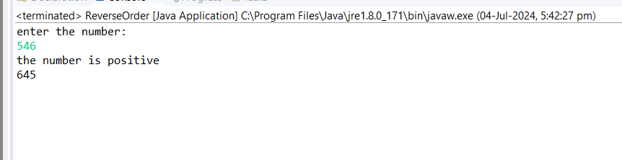

8.     Create a class Animal with a method makeSound() that prints "Some generic animal sound". Create another class Dog that extends Animal and overrides the makeSound() method to print "Bark". Write a main method to demonstrate calling the makeSound() method on an Animal reference holding a Dog object.

INPUT:-

// Define the Animal class

**class** Animal {

// Method to make a sound

**public** **void** makeSound() {

System.***out***.println("Some generic animal sound");

}

}

// Define the Dog class that extends Animal

**class** Dog **extends** Animal {

// Override the makeSound() method to provide a specific implementation

**public** **void** makeSound() {

System.***out***.println("Bark");

}

}

**public** **class** InheritanceOfAnimal {

**public** **static** **void** main(String[] args) {

// Create an Animal reference holding a Dog object

Animal myDog = **new** Dog();

// Call the makeSound() method

myDog.makeSound(); // This will print "Bark"

}

}

OUTPUT:-

